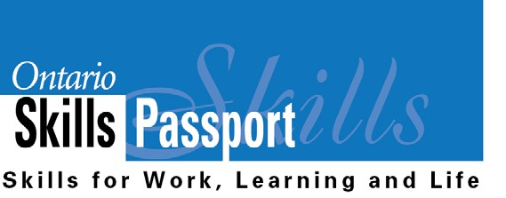
My Essential Skills - Junior
Individual Assignment
I am someone who...

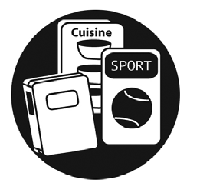  Loves reading magazines, comics,  chapter books... anything! | Loves to write stories or  keep a diary. | 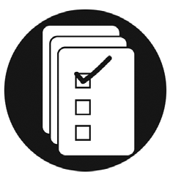  Can use an agenda to record due dates for assignments.

Loves to use computers and explore new technology at home and in class. | Can add coins and bills. | 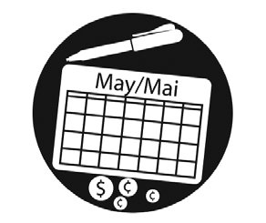  Can schedule time to complete homework and other activities like hockey practice or music lessons.

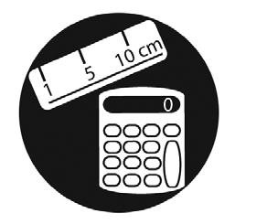  Loves to help measure ingredients to make a simple meal. | Can judge the suitability and reliability of using different websites for a project. | 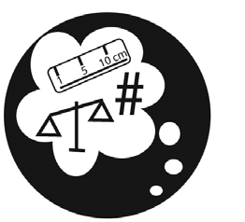  Can estimate the time it will take to read a book or complete an assignment.

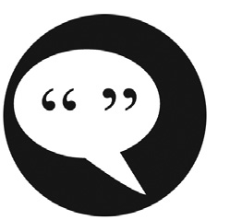  Loves to talk and listen to my friends. I like to answer questions and present my ideas to others. | 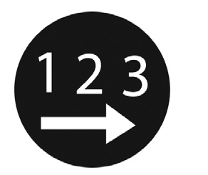  Likes to help organize events like school bake sales or parties. | 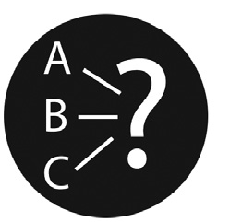  Can select the materials or equipment needed to complete a craft project or play a sport.

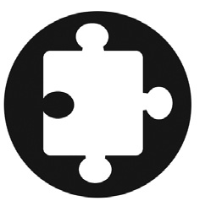  Can ask others to join our team when we don’t have enough people to play the game. | Loves to find out information about my favourite topic  (e.g., sports, movies, bands). | 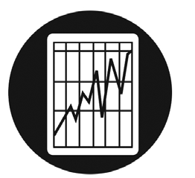  Can compare two foods to determine which one is the healthier choice.

